- Arjay Quilantang BSIT-3
Database Transactions: In your own words, explain why DB::transaction() is critical when implementing the "Transfer" feature (moving money from Account A to Account B). What happens if the system crashes after deducting money from Account A but before adding it to Account B?
- Real-Time Updates: Compare AJAX Polling (used in this exam) with WebSockets. Why did we choose AJAX Polling for this system? What is the main drawback of this method?
- Observers: What is the primary advantage of using an Eloquent Observer for balance updates instead of writing the balance update logic directly inside the Controller's store() method?
Answers:
- transaction() links the two steps take from A, give to B together. Both happen, or neither does. If the system fails after taking from A but before adding to B, transactions undo the withdrawal from A so no money vanishes. Without it, A loses funds and B never gets them.
- AJAX polling: browser checks for new data every 30 seconds. WebSockets: keep a constant connection so the server sends updates right away. We chose polling because it’s simple, works with basic Laravel and XAMPP, and instant updates aren’t needed. Downside: data is up to 30 seconds old, and some requests are empty, wasting resources.
- Balance logic sits in one place and runs automatically whenever a transaction is made no matter where it comes from. This keeps controllers clean and stops mistakes from forgetting to update balances. Writing the same logic in store() would mean copying it everywhere transactions are created.
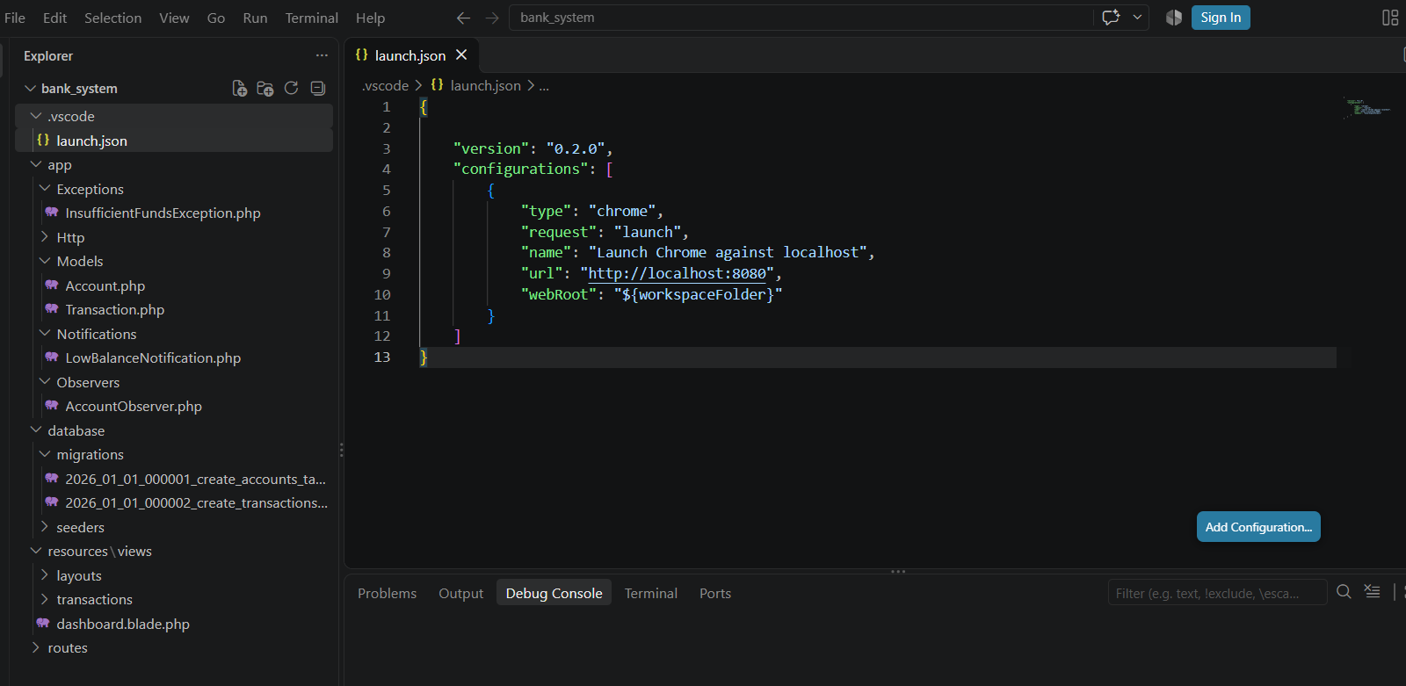
https://github.com/quilantanga49-lang/Bank_system/upload/main

